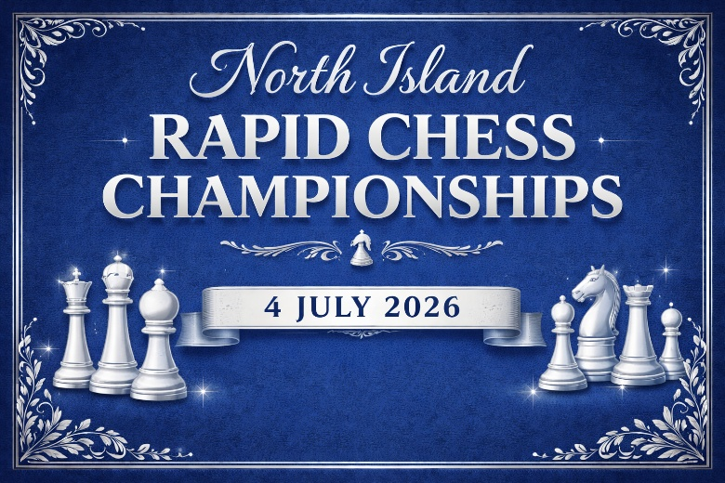

Venue: Waipuna Hotel & Conference Centre, 58 Waipuna Road, Mount Wellington, Auckland
Dates: Saturday 4 July 2026
Schedule:
Players Meeting | 9:00am
Round 1 | 9:30am
Round 2 | 10:50am
Round 3 | 12:10pm
Lunch | -----------
Round 4 | 2:00pm
Round 5 | 3:20pm
Round 6 | 4:40pm
Prizegiving | As soon as practically possible after Round 6

Format: Single group, six-round, open Swiss. Time control: 25 minutes + 5 seconds per move from move 1
Entry Fee: $60 Adults, $40 Juniors (born 2006 or later).
Capacity: Total entries limited to 100 (Venue Capacity)
Rating: NZCF and FIDE rated where possible. Non-NZL players must have or obtain a FIDE ID from their national federation.
Pairings and Rating-Based Prizes: NZCF ratings will be used for pairings and rating-based prizes. Players without ratings may be assigned a rating by the Chief Arbiter. The most recently published rating lists will be used – this will be the 2065-2 rating list to 30 June 2026 if available (if not then the 2026-1 list to 31 March will be used – that is what is currently loaded into the Vega files)
Half-point Byes: Up to two half point byes are available in any of the first three rounds. Notice should be given before the start of the tournament and can be given on the entry form.
Prize Fund: Guaranteed prize fund of $1,000
Organised by: New Zealand Chess Federation
How to Enter: https://www.trybooking.com/nz/BCYU
Further Details
There will be a players’ meeting at 9:00 AM. Players not present at the players meeting will not be paired in the first round unless the Chief Arbiter decides otherwise.
The North Island Rapid champion will be the highest-placed New Zealand player who is a member of a North Island club or lives in the North Island if not a member of any club.
Only one monetary prize may be won.
Prize giving will take place as soon as possible after completion of the final round.

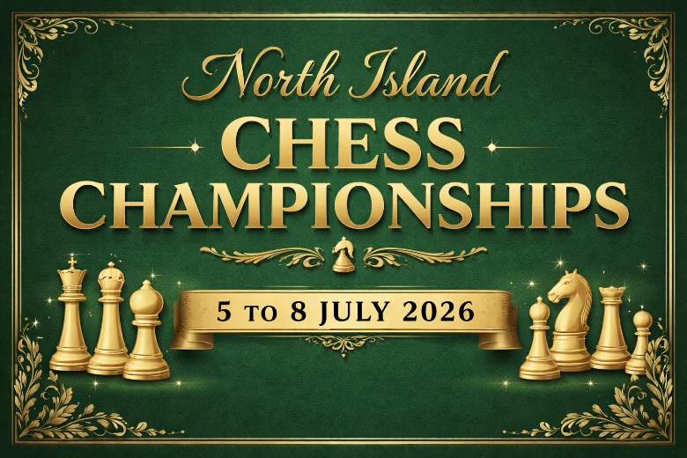

Venue: Waipuna Hotel & Conference Centre, 58 Waipuna Road, Mount Wellington, Auckland
Dates: Sunday 5 July to Wednesday 8 July 2026
Schedule: Two rounds per day, starting at 9:30 AM and 2:30 PM
Format: Single group, eight-round, open Swiss. Time control: 90 minutes + 30 seconds per move from move 1
Entry Fee: $120 Adults, $100 Juniors (born 2006 or later).
Capacity: Total entries limited to 80 (Venue Capacity)
Rating: NZCF and FIDE rated where possible. Non-NZL players must have or obtain a FIDE ID from their national federation.
Pairings and Rating-Based Prizes: NZCF ratings will be used for pairings and rating-based prizes. Players without ratings may be assigned a rating by the Chief Arbiter. The most recently published rating lists will be used – this will be the 2065-2 rating list to 30 June 2026 if available (if not then the 2026-1 list to 31 March will be used – that is what is currently loaded into the Vega files)
Half-point Byes: Up to two half point byes are available in any of the first four rounds. Notice should be given before the start of the tournament and can be given on the entry form.
Prize Fund: Guaranteed prize fund of $2,000
Organised by: New Zealand Chess Federation
How to Enter: https://www.trybooking.com/nz/BCYU
Further Details
There will be a players’ meeting at 9:00 AM on the first day. Players not present at the players meeting will not be paired in the first round unless the Chief Arbiter decides otherwise.
The North Island champion will be the highest-placed New Zealand player who is a member of a North Island club or lives in the North Island if not a member of any club.
Only one monetary prize may be won.
Prize giving will take place as soon as possible after completion of the final round.

Fair Play Regulations (for both Championship and Rapid events)

Prohibition of Mobile Phones and Electronic Devices
Phones and electronic devices may be kept in a bag (placed under the table or player’s chair) or in a jacket pocket (provided the jacket remains placed over the back of the player’s chair). Such devices must still be switched off.
Storage facilities will be available for these devices which should still be switched off. This includes smart watches but not standard analogue or digital watches.
This measure is essential to prevent any potential use of unauthorized assistance during the games.

Scanners
Players are subject to random scanning for electronic devices by an arbiter using a handheld electronic scanner whilst in the playing venue or on entering or leaving the playing venue.
This will aid in ensuring that no prohibited items are brought in and that the security of the venue is maintained.

Strict Penalties for Violations
Any violation of the Fair Play Measures will result in an immediate loss for the offending player.
In cases where cheating is suspected, the entire game result will be annulled, and the matter will be reported to FIDE for a thorough investigation.

Searches
Furthermore, the arbiter may require a player to allow his/her clothes, bags, other items or body to be inspected, in private. The arbiter or person authorised by the arbiter shall inspect the player and shall be of the same gender as the player. If a player refuses to cooperate with these obligations, the arbiter shall take measures in accordance with Article 12.9. of the FIDE Laws of Chess.

Photography
Spectators may take photos during the first 5 minutes of a round.

By implementing these measures, we aim to uphold the highest standards of fair play and sportsmanship at this official New Zealand Chess Federation event. We appreciate the cooperation of all participants in adhering to these protocols, as they are crucial for maintaining the integrity of the competition.

