

134th New Zealand Chess Congress
2-12 January 2027

Alexandra Park - Auckland

Proudly hosted by the New Zealand Chess Federation

Incorporating the:
- New Zealand Chess Championships
- New Zealand Major Open
- New Zealand Junior & Age Group Chess Championships
- New Zealand Junior U1000 Chess Championships
- New Zealand Rapid Chess Championships
- New Zealand Lightning Chess Championships
- Auckland Open

Minimum Prize Fund of $12,000
Free Entry for GMs, IMs, WGMs and WIMs

Alexandra Park
Cnr Greenlane West & Manukau Road
Epsom
Auckland
New Zealand
New Zealand Chess Championships & New Zealand Major Open
2-12 January 2027

Format: 2 separate 9 Round Swiss tournaments.
Time Control: 90 minutes for the first 40 moves followed by 30 minutes for the rest of the game with an additional 30 seconds per move from move one.
Check-in: Players must check in between 10:00am and 1:30pm on the 2nd of January either in person or by text message to the organiser (021 111 5662) or not be paired in the first round.
Players Meeting: 1:30pm on 2 January 2027
Round Times: 2:00pm every day
Entry Fees – NZ Championships
Before 1 Dec (early bird entry) | $220
1 Dec or Later | $240

Entry Fees – NZ Major Open
Before 1 Dec (early bird entry) | $150
1 Dec or Later | $170

Rating Requirements: Players must have an NZCF or FIDE rating of 1800 or above to enter the NZ Championships (the organisers reserve the right to allow player rated below 1800 to enter the NZ Chess Championships)
Players must have an NZCF rating below 2100 or FIDE rating below 2000 to enter the Major Open.
The organiser reserves the right to allow players below the minimum rating to enter the New Zealand Chess Championships.
Prizegiving will be at approximately 7:30pm during the banquet dinner.
Open to entries from players of all nationalities. The highest-placed NZ players in each tournament will be the 2027 New Zealand Champion and Major Open Champion.
Rating bands (U1400 for example) in the prize funds subject to change depending on final entries.

Prize fund
*****
NZ Chess Championships
1st | $1,600
2nd | $1,100
3rd | $750
4th | $500
5th | $400
U2100 1st | $200
Minimum of $4,550

NZ Major Open
1st | $1,200
2nd | $800
3rd | $500
U1700 1st | $200
U1400 1st | $200
Minimum of $2,900





134th New Zealand Chess Congress Auckland 2-12 January 2027
134th New Zealand Chess Congress Auckland 2-12 January 2027
Prizegiving and Banquet Dinner
10 January 2027

Prizegiving
Time: Approx 7:30pm
Venue: Alexandra Park, TBC
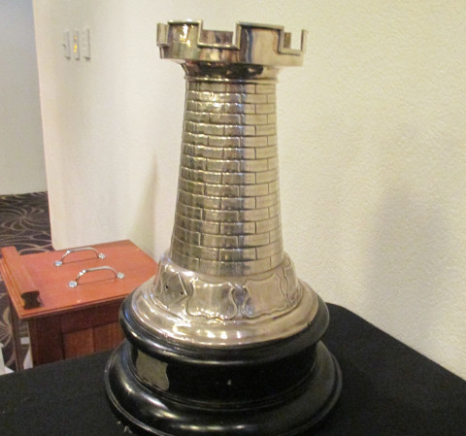
Banquet
Time: Approx 7:00pm
Venue: Alexandra Park, TBC
Further details including menu and cost will be made known during the first few rounds of the Championships
Attendance must be confirmed by 5 January 2027
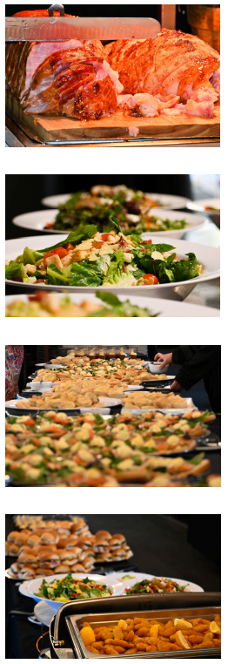







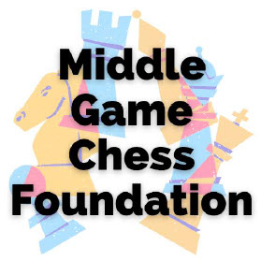

134th New Zealand Chess Congress Auckland 2-12 January 2027
New Zealand Rapid Chess Championships
11-12 January 2027

Format: 9 Round Swiss tournament
Competition Rules: Article A.5 of the Laws of Chess will apply.
Time Control: 25 minutes for the game with an additional 5 seconds per move starting from move one.
Playing Schedule

Monday 11 January |  | Tuesday 12 January
Entries Close | 11:45am | Round Five | 09:00am
Players Meeting | 1:00pm | Round Six | 10:15am
Round One | 1:30pm | Round Seven | 11:30am
Round Two | 2:45pm | Lunch | 12:45pm
Round Three | 4:00pm | Round Eight | 1:30pm
Round Four | 5:15pm | Round Nine | 2:45pm

Prizegiving will follow round 9 at approximately 4:30pm.
Entry Fee: $70. No late fee – entries accepted until 11:45am, 11 January 2027.
Open to entries from players of all nationalities. The highest-placed NZ player will be the 2027 New Zealand Rapid Champion.
Rating bands (U1400 for example) in the prize funds subject to change depending on final entries.

Prize fund
*****
NZ Rapid Chess Championships
1st | $500
2nd | $300
3rd | $200
U2000 1st | $100
U1700 1st | $100
U1400 1st | $100
Minimum of $1,300

134th New Zealand Chess Congress Auckland 2-12 January 2027
New Zealand Lightning Chess Championships
11 January 2027

Format: 9 Round Swiss tournament
Competition Rules: Article B.4 of the Laws of Chess will apply.
Time Control: 3 minutes for the game with an additional 2 seconds per move starting from move one.
Players Meeting: 8:45am on 11 January 2027.
Round Times: First round at 9:00am, subsequent rounds will be paired after the last game finishes. Prizegiving will follow round 9 at approximately 11:30am.
Entry Fee: $40. No late fee – entries accepted until 8:30am, 11 January.
Open to entries from players of all nationalities. The highest-placed NZ player will be the 2027 New Zealand Lightning Champion.
Rating bands (U1400 for example) in the prize funds subject to change depending on final entries.

Prize fund
*****
NZ Lightning Chess Championships
1st | $300
2nd | $200
3rd | $150
U2000 1st | $100
U1700 1st | $100
U1400 1st | $100
Minimum of $950

134th New Zealand Chess Congress Auckland 2-12 January 2027
New Zealand Junior & Age Group Chess Championships & Junior U1000 Chess Championships
3-9 January 2027

Format: 2 separate 7 Round Swiss tournaments.
Time Control: 60 minutes for the game with an additional 30 seconds per move starting from move one.
Check-in: Players must check in between 8:00pm and 8:30am on the 3rd of January either in person or by text message to the organiser (021 111 5662) or not be paired in the first round.
Players Meeting: 8:30am on 3 January
Round Times: 9:00am every day

Entry Fees – NZ Junior and Age Group Chess Championships
Before 1 Dec (early bird entry) | $80
1 Dec or Later | $100

Entry Fees – NZ Junior U1000 Chess Championships
Before 1 Dec (early bird entry) | $70
1 Dec or Later | $90

Prizegiving will be held after the last game on 9 January at approx. 12:30pm.
The NZ Junior and Age Group Championships are open only to juniors i.e. players born on or after 1/1/2007.
The highest-placed NZ player in each age group will be the 2027 New Zealand Champion for that age group. The highest-placed NZ player and female NZ player enrolled at and attending primary or secondary school in 2025 will be the 2026 NZ Schoolpupil Champion and NZ Schoolgirl Champion respectively. The highest-placed player overall will be the 2027 NZ Junior Champion and highest-placed female player over will be the 2027NZ Junior Girls Champion.
Age group eligibility is based on the player’s age on 31 December 2026, and only in the age group closest to the player’s age e.g. a 13-year-old player is eligible for the under 14 title, but not the under 16 title.
The New Zealand Junior U1000 Chess Championships:
This event is only open to those juniors (see above) who have a NZCF rating of under 1000 in the latest rating list (or who are unrated). Note that this event will NOT be FIDE rated. This event requires a minimum of 6 players. – should less than 6 players enter, they will be given the option of moving up to the NZ Junior and Age Group Chess Championships or have their entry fee refunded.

We collect your/your child's personal information in order to:
- Enter you/your child into the appropriate events at the 133rd New Zealand Chess Congress
- Contact you/your child about the 133rd New Zealand Chess Congress
We share this information with:
- NZCF Councillors, employees, contractors and anyone else associated with NZCF in order to check compliance with legislation, NZCF regulations and contact players as required about compliance, payments, chess events and activities, and to check information currently held
- FIDE (international chess federation) to maintain FIDE rating lists and any other FIDE requirements and reporting (reporting will be anonymised to the maximum extent possible) and NZCF members (clubs) and tournament organizers to check and correct information currently held, and facilitate chess events and rating reports – this will usually be limited to NZCF and FIDE ID numbers, name, date of birth and email address
- You are not required to provide information requested but if you don't, you/your child may not be able to enter or participate in the 133rd New Zealand Chess Congress

You have the right to ask for a copy of any personal information we hold about you, and to ask for it to be corrected if you think it is wrong.
If you’d like to ask for a copy of your information, or to have it corrected, please contact the Chief Organiser – Richie Christie chessventures@gmail.com

Prize fund
*****
NZ Junior & Age Group Chess Championships
1st | $500
2nd | $300
3rd | $200
NZ Schoolgirls Champion | $150
U16 Champion | $50 + Book
U14 Champion | $50 + Book
U12 Champion | $50 + Book
U10  Champion | $50 + Book
U8 Champion | $50 + Book
Minimum of $1,550 including 5 Book Prizes

NZ Junior U1000 Championships
1st | $200
2nd | $150
3rd | $100
Minimum of $450

Format: 5 Round Swiss tournament
Time Control: 60 minutes for the game with an additional 30 seconds per move from move one.
Check-in: Players must check in between 8:00pm and 8:30am on the 4th of January either in person or by text message to the organiser (021 111 5662) or not be paired in the first round.
Players Meeting: 8:30am on 4 January
Playing Schedule:
Round 1 – Monday 4 January 9:00am
Round 2 – Tuesday 5 January 9:00am
Round 3 – Wednesday 6 January 9:00am
Round 4 – Thursday 7 January 9:00am
Round 5 – Friday 8 January 9:00am
Entry Fee: $60

Note: This event requires a minimum of 6 players. Should less than 6 players enter, they will have their entry fee refunded.

134th New Zealand Chess Congress Auckland 2-12 January 2027
Auckland Open
4 to 8 January 2027

Prize fund
*****
Auckland Open
1st | $150
2nd | $100
3rd | $50
Minimum of $300

134th New Zealand Chess Congress Auckland 2-12 January 2027
Regulations

NZCF and FIDE Rating: Tournaments will be NZCF-rated and FIDE-rated where possible.
Pairings and Rating-Based Prizes: NZCF ratings will be used for pairings and rating-based prizes except for the NZ Championships and NZ Lightning Championship which will use FIDE blitz ratings. Players without ratings may be assigned a rating by the Chief Arbiter. The most recently published rating lists will be used (January for NZCF and FIDE).
Pairings: Pairings will be done with the assistance of Vega. For standard tournaments, pairings will not be final i.e. published for the purposes of FIDE regulations until 30 minutes before the round start time.
NZ Player: Per NZCF regulations, NZ citizen or a player who is normally resident in New Zealand and has been resident in New Zealand for at least one year prior to Congress.
Half-point Byes: Players may take 1 half-point bye in tournaments with standard time controls i.e. all events except for the NZ Rapid or Lightning Championships. Half-point byes may only be taken during the first half of the tournaments i.e.
- NZ Championships / NZ Major Open – rounds 1 to 5
- NZ Junior / NZ Junior U1000 – rounds 1 to 4
- Auckland Open – rounds 1 to 3
Additional byes or byes after round 5 in any tournament can be requested but will be 0-point byes.
Multiple Prizes and Tiebreaks: Players may not win more than one cash prize in a tournament – the highest cash prize will be paid, and other prizes will be passed down to the next highest-placed player. Titles and cash prizes will be shared by eligible players on the same score, and ties will not be broken.
Players Meetings: Player’s meetings will be held for all tournaments as noted in the individual tournament timetables. Players who do not attend the players meeting for a tournament may be excluded from the first round of that tournament.
Defaults: Default time is 30 minutes after the start of the round.
Appeals: A player may appeal against a decision of the Arbiter in a tournament other than the NZ Lightning Championship (no appeals allowed). Appeals Committees for each tournament will be appointed by the Organiser from the players. Appeals must be lodged in writing within 30 minutes of the end of the game (10 minutes for the NZ Rapid Championship). A fee of $100 will apply, to be refunded if the appeal is successful or otherwise at the discretion of the Appeals Committee.
Fair Play Measures: In alignment with the recommendations put forth by the Fédération Internationale des Échecs (FIDE), we are committed to reinforcing the protection mechanisms of fair play for the upcoming New Zealand Congress 2026. The integrity of the game is paramount, and these enhanced measures are designed to ensure a level playing field for all participants.

134th New Zealand Chess Congress Auckland 2-12 January 2027
Primary Measures
Prohibition of Mobile Phones and Electronic Devices
During a game, players are forbidden to have a mobile phone, electronic means of communication or any device capable of suggesting chess moves in the playing venue. Storage facilities will be available for such devices which should still be switched off. This includes smart watches but not standard analogue or digital watches.
This measure is essential to prevent any potential use of unauthorized assistance during the games.
Introduction of Scanners
Players are subject to random scanning for electronic devices by an arbiter using a handheld electronic scanner whilst in the playing venue or on entering or leaving the playing venue.
This will aid in ensuring that no prohibited items are brought in and that the security of the venue is maintained.
Strict Penalties for Violations
Any violation of the Fair Play Measures will result in an immediate loss for the offending player.
In cases where cheating is suspected, the entire game result will be annulled, and the matter will be reported to FIDE for a thorough investigation.
Searches
Furthermore, the arbiter may require a player to allow his/her clothes, bags, other items or body to be inspected, in private. The arbiter or person authorised by the arbiter shall inspect the player and shall be of the same gender as the player. If a player refuses to cooperate with these obligations, the arbiter shall take measures in accordance with Article 12.9. of the FIDE Laws of Chess.

134th New Zealand Chess Congress Auckland 2-12 January 2027
By implementing these measures, we aim to uphold the highest standards of fair play and sportsmanship at the New Zealand Congress. We appreciate the cooperation of all participants in adhering to these protocols, as they are crucial for maintaining the integrity of the competition.
Photos: Spectators may take photos during the first 5 minutes of a round.
Covid-19: If Congress is cancelled due to Covid-19, entry fees will be refunded.
Organisers will not be responsible for any further compensation to affected players.
Small Entry: If fewer than 40 total entries are received in the NZ Championship and Major Open, the events will be combined with an adjusted prize fund. The Major Open Champion will be the highest placed NZ player with either NZCF or FIDE rating below 2100.

Small Entry to NZ Championship: If fewer than 20 players enter the NZ Championship, players may be asked to move up from the Major Open.
Prize funds: The Small Entry regulation above notwithstanding, prize funds shown are the minimum, additional or increased prizes may be offered depending on entry numbers.

134th New Zealand Chess Congress Auckland 2-12 January 2027
Accommodation

TBC

.

134th New Zealand Chess Congress Auckland 2-12 January 2027
Entries, payment and enquiries

Entries & Payment: https://www.trybooking.com/nz/BDMR
Enquiries: admin@newzealandchess.co.nz

