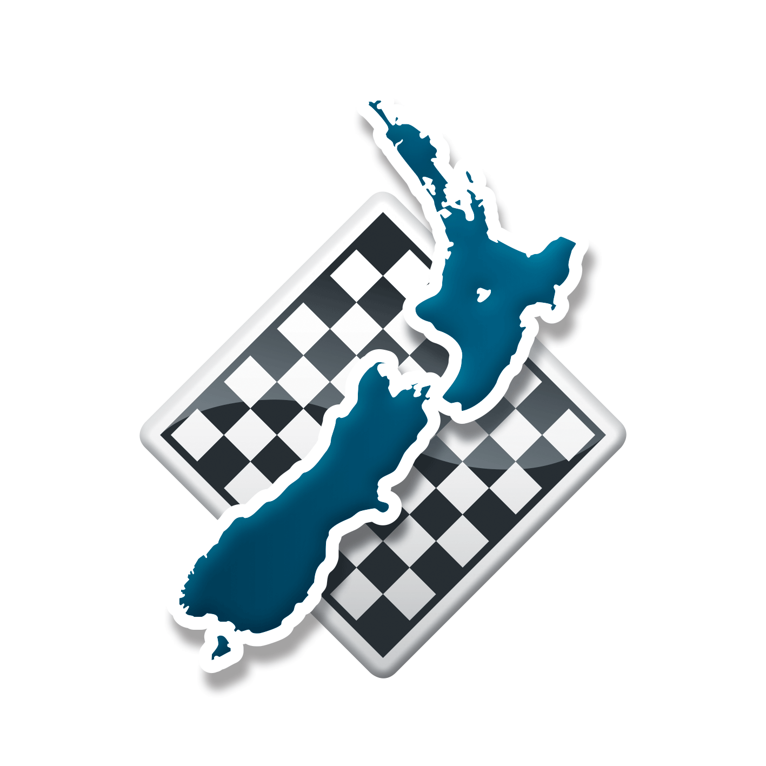
New Zealand Chess Federation Privacy Policy
  - Adopted by NZCF Council 30/11/2025

Your Right to Privacy
The New Zealand Chess Federation (NZCF) understands the importance of protecting your right to privacy and have therefore prepared this privacy policy (Privacy Policy) to help you understand how we aim to protect the privacy of your personal information.
In this document we outline what personal information we might collect, hold and use about you and why we need this information. NZCF complies with the Privacy Act 2020 (the Privacy Act) when dealing with personal information.
The Privacy Act contains 13 Information Privacy Principles that regulate, among other things, how organisations collect, store and protect the quality of personal information. Also regulated is how organisations should use and share personal information with other organisations. The Information Privacy Principles form part of all our procedures and policies and the way personal information is administered.
By providing your personal information to us, including by joining NZCF, accessing our services or otherwise engaging with us, you acknowledge that you have read and understood this Privacy Policy and you authorise the collection, use and disclosure of your personal information by NZCF in accordance with this Privacy Policy.

Updates to this Policy
This Privacy Policy will be reviewed from time to time to take account of changes to our operations and practices and the changing organisational environment. The most current version of this Privacy Policy is located on the NZCF website: https://newzealandchess.co.nz/privacy/ .

What Personal Information Will NZCF Collect About Me?
Your personal information will be collected and held by NZCF.
NZCF collects personal information from members, affiliates, competition organisers, arbiters and other associates to assist in providing our range of services. The type of personal information we collect about you may include your name, date of birth, gender, address, region, telephone number, email address, society, company and/or business information and other details relevant to NZCF membership and the services NZCF provides. We are also required to collect and store some personal information by the Incorporated Societies Act 2022.
Except as otherwise permitted by law, NZCF collects personal information when users use the NZCF website to lodge their personal details, society, company and/or business details and information, and when users change or update any of these details, or if users send NZCF documents containing personal information.
We will collect personal information (where reasonable and practicable) directly from you. We may at times collect your personal information directly from other sources, particularly clubs and competition organisers.

Risks of Using the Internet
You should note that there are security risks in transmitting information via the internet. You should assess these potential risks when deciding whether to use our online services. If you do not wish to transmit information via the NZCF website, there are other ways in which you can provide this information, such as by mail or telephone.

Collection of Browser Information
When you browse the NZCF website, our service provider logs the following information for statistical purposes:
- your server address;
- top level domain name (for example .com, .gov, .au, etc.);
- the date and time of your website visit;
- the pages you looked at;
- the documents you downloaded;
- the previous site you visited; and
- the type of browser you used.
Generally this information is not personally identifiable data, but to the extent it is considered personal information for the purposes of the Privacy Act, we will comply with our obligations under the Privacy Act when processing that information.
We will not try to identify users or their browsing activities except, in the event of an investigation, where a law enforcement agency may exercise a warrant to inspect the service provider's logs. The NZCF website is 'cookie' free, which means we will not send you any unsolicited information after you have accessed our website. We will only record your email address if you send us a message. It will not be added to a mailing list unless specifically requested by the user.

Why Does NZCF Need My Personal Information?
The personal information NZCF collects about you is used to correspond with you and to provide you with other services from NZCF e.g. calculating and maintaining ratings.
If you choose not to provide your personal information, it may mean that we will not be able to provide these services to you.
There are other organisations that are connected to the services we provide to you and which may have access to your personal information. They are:
- Member and affiliated organisations of NZCF; and
- Web development companies – organisations contracted to develop and maintain the NZCF website; and
- Other third-party service providers that we may engage to assist us in carrying out our functions and delivering services; and
- Auditors and Regulators – organisations that ensure NZCF are complying with legislation and contractual obligations; and
- Any other organisations that we may be permitted or required by law or other NZCF bylaws, regulations or policies to disclose personal information to.

Can I see the Personal Information NZCF has about me?
Subject to the exceptions set out in the Privacy Act, you have the right to access your personal information that NZCF holds about you, and to request a correction to your personal information. If you want to exercise either of these rights, please contact NZCF using the contact details below.

How Can I Contact NZCF?
If you want further information on how NZCF handles personal information, or if you have any questions about this Privacy Policy, please email NZCF:
Admin@newzealandchess.co.nz
If you are unsatisfied with the resolution of any questions, you can contact the Office of the Privacy Commissioner at: PO Box 10-094, The Terrace, Wellington 6143, phone: 0800 803 909, http://privacy.org.nz.

Using and Sharing Information
NZCF will use your personal information to provide our services to you e.g. NZCF ratings. We may also use your personal information for related reasons, such sending you emails about competitions, publicity, marketing campaigns etc. We will give you the opportunity to opt out of any future emails offering services etc. at the time of mailing to you. We are legally required to communicate by email in some instances e.g. notice of NZCF’s annual general meeting – these types of emails are not offering services and are not able to be opted out of.
NZCF will share your information with FIDE (international chess federation) if required by FIDE regulations e.g. for players in competitions rated and/or organised by FIDE. NZCF will share your information in New Zealand with clubs and competition organisers and arbiters.
NZCF will publish lists of players and members on the NZCF website. These lists will contain personal information as outlined in the rating bylaws, membership bylaws and any other relevant bylaws, regulations and/or policies. Where you play in competitions which publish results and other competition information on the NZCF website, your personal information will be included in those results and other competition information.
Sharing and publishing of personal information will be limited to necessary information e.g. we will not publish full date of birth, addresses (physical or email) or phone numbers.

Keeping Information Accurate and Up To Date
NZCF will ensure that the personal information we collect is accurate and complete. We will do this by ensuring that you have the opportunity to advise us of changes to your personal information at all times.

Keeping Information Secure
NZCF will take reasonable steps to keep your personal information safe from loss, unauthorised access, or other misuse. We do not share your information with anyone who doesn't have authority to see your information.
We generally hold your information in New Zealand. However, certain personal information may be stored outside of New Zealand by our third party service providers. Where personal information is disclosed to any third party outside of New Zealand we will ensure that such third party is subject to comparable privacy laws to New Zealand or is required to protect the personal information in a way that is comparable to New Zealand’s privacy laws.

Last updated: 30/11/2025

