
NEW ZEALAND CHESS FEDERATION

Trial Hybrid Bledisloe Cup and Blackburn Cup Competitions 2024

At the New Zealand Chess Federation Council meeting on 18 February 2024, it was agreed to revive the Bledisloe and Blackburn interclub competitions.
The current tournament rules governing these bodies have been waived in favour of a trial hybrid chess competition for 2024 while the current rules are reviewed and updated to reflect the changes in technology and chess demographics.
Richie Christie has been appointed the coordinator for this trial competition. He will also serve as the Deputy Chief Arbiter.
Richard Christie 021 111 5662 admin@newzealandchess.co.nz

Details / Regulations of the 2024 trial competition:

Competition: Bledisloe Cup & Blackburn Cup
Type: Hybrid
Format: Swiss Teams
Boards per team: 6
Board Order: Board order will be by NZCF Standard Rating at 31 March 2024 (end of 2024 1st Quarter – expected to be published mid April)
Squads: Clubs can nominate a squad of 12 players at the start of the competition, all teams must be made up from that squad.
Player Eligibility: Players must be members of their respective club.
Team Eligibility: Clubs from the metropolitan areas would be eligible to win the Bledisloe Cup (Auckland, Wellington City, Dunedin and Christchurch). Clubs from non-metro areas (i.e. all other clubs) will be eligible to win the Blackburn Cup (this is in keeping with the original competition)
Rounds: 4 if 16 or less teams, 5 if more than 16 teams
Time Control: 60 min + 30 sec
Platform: Tornelo – all squad member should sign up with Tornelo (if not already members) – it is free.
Dates: 1 month per round, June, July, August, October and November (November only if 5 rounds are played). The draw will be published on the first day of the month (or earlier if results allow). Clubs will have a month to arrange a date/time to play their opposing club. Reasonable efforts to find a suitable compromise will be both expected and appreciated! Leaving September clear due to Olympiad.
The draw for the next round will be published as soon as possible after the last match in the pervious round has been completed.
Venues: Clubs to provide their own venue
Internet connection: Each club is responsible for their own internet connection(s)
Equipment: Each club is responsible for their own equipment. Players need to provide (and play on) a laptop (or equivalent). Tablets and / or mobile phones cannot be used (mobile phones can be used to provide mobile hot spots with the permission of the local and chief arbiter. Clubs need to provide a laptop and camera – to show a panoramic view of the playing venue.
Meeting: A Zoom) meeting will be set up for each match, each club should join and provide a panoramic video view of the venue (as above). Players have the option to join the meeting with a front facing camera.
Arbiters: Each club to have a local arbiter on site for every match. IA Craig Hall will be the Chief Arbiter and NA Richie Christie will be the Deputy Chief Arbiter (the local arbiter should ideally be at least an NA, but can just be a non-playing club member – ideally one with some arbitering/DOP experience.
Technical: Suggested that each club have someone available to assist with any technical issues – FIDE terms these ‘Local Technical Arbiters’
Scoring: Each match result will be determined by the total of the 6 board scores (1,0.5,0). Match win = 2 Match Point, a Match draw = 1 Match Point, teams paired according to Match Points.
Tie Breaks: Final placings to be determined on Match Points, then Direct Encounter, then Game Points
Notifying the Tournament Co-ordinator: The names of the 6 players for a match should be emailed to Richie Christie admin@newzealandchess.co.nz 2 days before the match date (which should also be given to Richie). A match / tournament will then be set up on Tornelo and the details emailed back to the club/players.
Richie should also be notified of the full match result
Technical Meeting: There will be a technical meeting before the end of April to run clubs through processes and allow for questions
Disputes: In the case of any dispute over any rules relating to the Laws of Chess, the decision of the Chief Arbiter IA Craig Hall will be binding. In the case of any other dispute, the decision of the Tournament Co-ordinator, Richie Christie will be binding.
What is Hybrid Chess?
A hybrid tournament as defined by FIDE is a format where the games are played online, but the participants are physically present in a public place like a club, federation headquarters, hotel, et cetera under the supervision of an arbiter.
Put simply, for this event, 6 players each with their own laptop, in a single venue, hooked up to the internet via wifi or mobile hotspot, with the option of also using a physical board, playing online versus another player from another club.
Invercargill-Southland Chess Club has played both an interclub match and an interclub tournament using this format – playing against some Australian chess clubs.
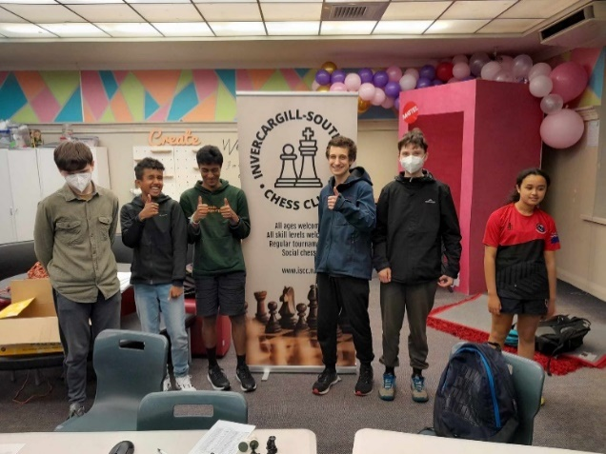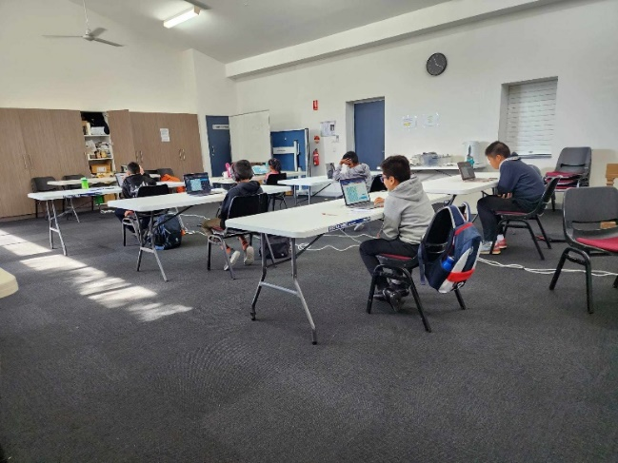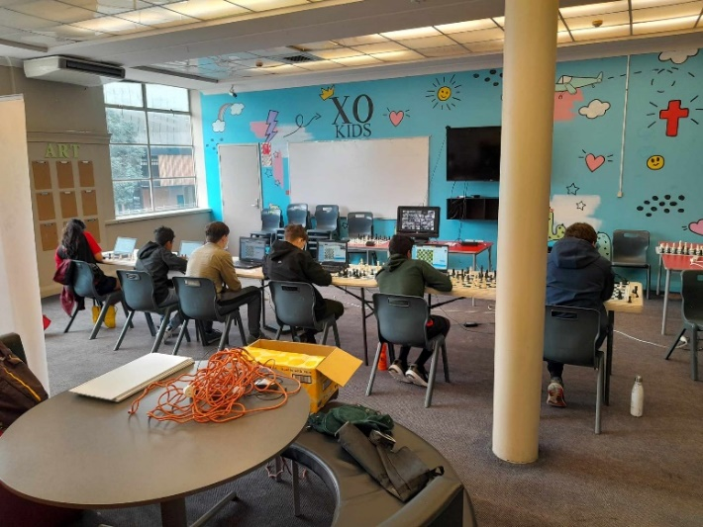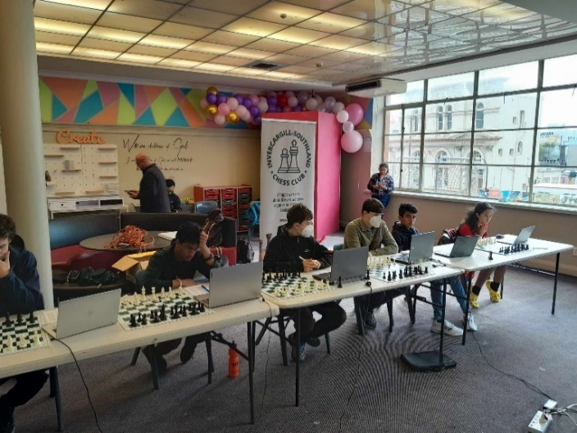
FIDE Regulations: https://rcc.fide.com/wp-content/uploads/2022/12/Annex_6.4-Fide-Online-Chess-
Regulations.pdf

Will the competitions be rated?
Not during this trial year. It is something we can look at going forward.

If we are an Auckland club playing another Auckland club, can we play a physical match?
Yes, at least during this trial year – it makes practical sense and might well be easier than a hybrid match.

How do I use physical board in conjunction with playing online?
As can be seen in some of the photos of the ISCC events, there is this option
The boards are not to be used for analysis.
The correct order of moving is:
1 Receive opponents move online.
2 Make that move on the physical board
3 Make your reply on the physical board
4 Make your reply on the online platform
The online game is the official record of the position and time ie. the game

NEW ZEALAND CHESS FEDERATION

Trial Hybrid Bledisloe Cup and Blackburn Cup Competitions 2024

Team Entry Form:
Club |  |  | Club Email
Captain (can be player) |  | Email |  | Cell Number:
Local Arbiter |  | Email |  | Cell Number:
Local Technical Arbiter |  | Email |  | Cell Number:
Player 1 |  |  |  | NZCF ID
Player 2 |  |  |  | NZCF ID
Player 3 |  |  |  | NZCF ID
Player 4 |  |  |  | NZCF ID
Player 5 |  |  |  | NZCF ID
Player 6 |  |  |  | NZCF ID
Player 7 |  |  |  | NZCF ID
Player 8 |  |  |  | NZCF ID
Player 9 |  |  |  | NZCF ID
Player 10 |  |  |  | NZCF ID
Player 11 |  |  |  | NZCF ID
Player 12 |  |  |  | NZCF ID

Please email this last page (ie. entry form) to Richie Christie by 11 May, please.
admin@newzealandchess.co.nz

